Coursework Cover Sheet
Students should complete the input fields contained in this form and attach it in front of your formal assessment submission. All fields within this form are required. Please ensure that check boxes and radio buttons are appropriately selected. The last three questions are just for you to personally consider.

Department and assessment information:
School Name: Engineering and Computing
Assessment title: Assignment 2: Car Race
Course Title: Computer Games Development / Software Engineering / Computer Science
Module Title: Games Concepts
Module Code: CO1301
Year of Study: 2024-25

Academic Misconduct / Plagiarism Declaration
By attaching this front cover sheet to my assessment I confirm and declare that I am the sole author of this work, except where otherwise acknowledged by appropriate referencing and citation, and that I have taken all reasonable skill and care to ensure that no other person has been able, or allowed, to copy this work in either paper or electronic form, and that prior to submission I have read, understood and followed the University regulations as outlined in the Academic Integrity Policy and Procedure for Academic Misconduct

Have you checked the following? This will help your assessment achievement.
I have applied the learning outcomes for this module ☒
I have checked for Academic Integrity via Turn-it-in ☐
I have followed the guidance in the Assessment Brief and have not used AI to boost my grade unfairly. ☒
I have used references in accordance with instructions in the Assessment Brief ☒
I have proofread my work for spelling, grammar and punctuation. ☒
I have checked that the word count/size of this submissions accords with the guidance provided in the Assessment Brief.☒

Well-being
We wish to support any student who is experiencing mitigating circumstances which prevents students from performing to the best of their ability when completing or submitting assignments. If you are experiencing such circumstances, then you may apply for Mitigating Circumstances. Wherever possible this must be done prior to handing in your assignment.

Do you need to apply for mitigating circumstances for this assignment No

Please refer to the Mitigating Circumstances Policy

Questions you may wish to consider:
- Have I allowed sufficient time to prepare this assessment?

- Have I reflected on previous feedback and made improvements in accordance with advice?

- What grade am I expecting?

Documentation

- Expected Grade:

- Lower Second classification (50%+) – Milestone 2.

- Hover Car lengths:

- Length of the hover car in TL engine units = 3 units.

$$Car length=3*0.5= 1.5 meters$$

- Length of the hover car in meters = 1.5 meters.

- Scale of all the objects:

- In this assignment I have used a scale to convert TL engine units to meters. (So, it means that 2 TL engine units = 1 meter)

“kScale = 0.5”
- Coefficient of Drag:

- I have used a global constant to define the coefficient of drag as,
- “Const float kDragCoefficient = 0.02.f”

- Maximum Speed without the boost:

- $Speed in\frac{kmp}{h}=240 kmp/h$
- $Speed in\frac{m}{s}=\frac{240}{3.6}=66.67\frac{m}{s}$
- $Speed in miles per hour mph=240 kmph*0.62= 149.12 mph$

- Maximum thrust force:
- A global constant has been declared as,
- “Const float kThrustForce = 120.0f”
- So, acceleration in meters per second

- $\frac{120.0}{0.5} =60.0 m/s2$

- Collisions:

- Sphere to Box Collision (sphereToBox) This collision is used to detect collisions between the car (act as sphere) and the objects like checkpoints, isles and walls (act as boxes). It calculates the closest point on the box to the sphere’s centre and checks if the distance between these points is less than the sphere’s radius.
- Sphere to Sphere Collision (sphereToSphere) This collision is used to detect collisions between the centres of the two spheres and checks if it is less than the sum of their radii. (Sphere as car and sphere as checkpoints)

- Collision resolution (resolveCollision) when collision is detected, the car’s momentum vector is reflected to make a bounce. This is calculated using the collision normal (the vector perpendicular to the surface of the objects) and moves the car slightly away from the collision’s point to prevent getting stuck.

- Scale map:
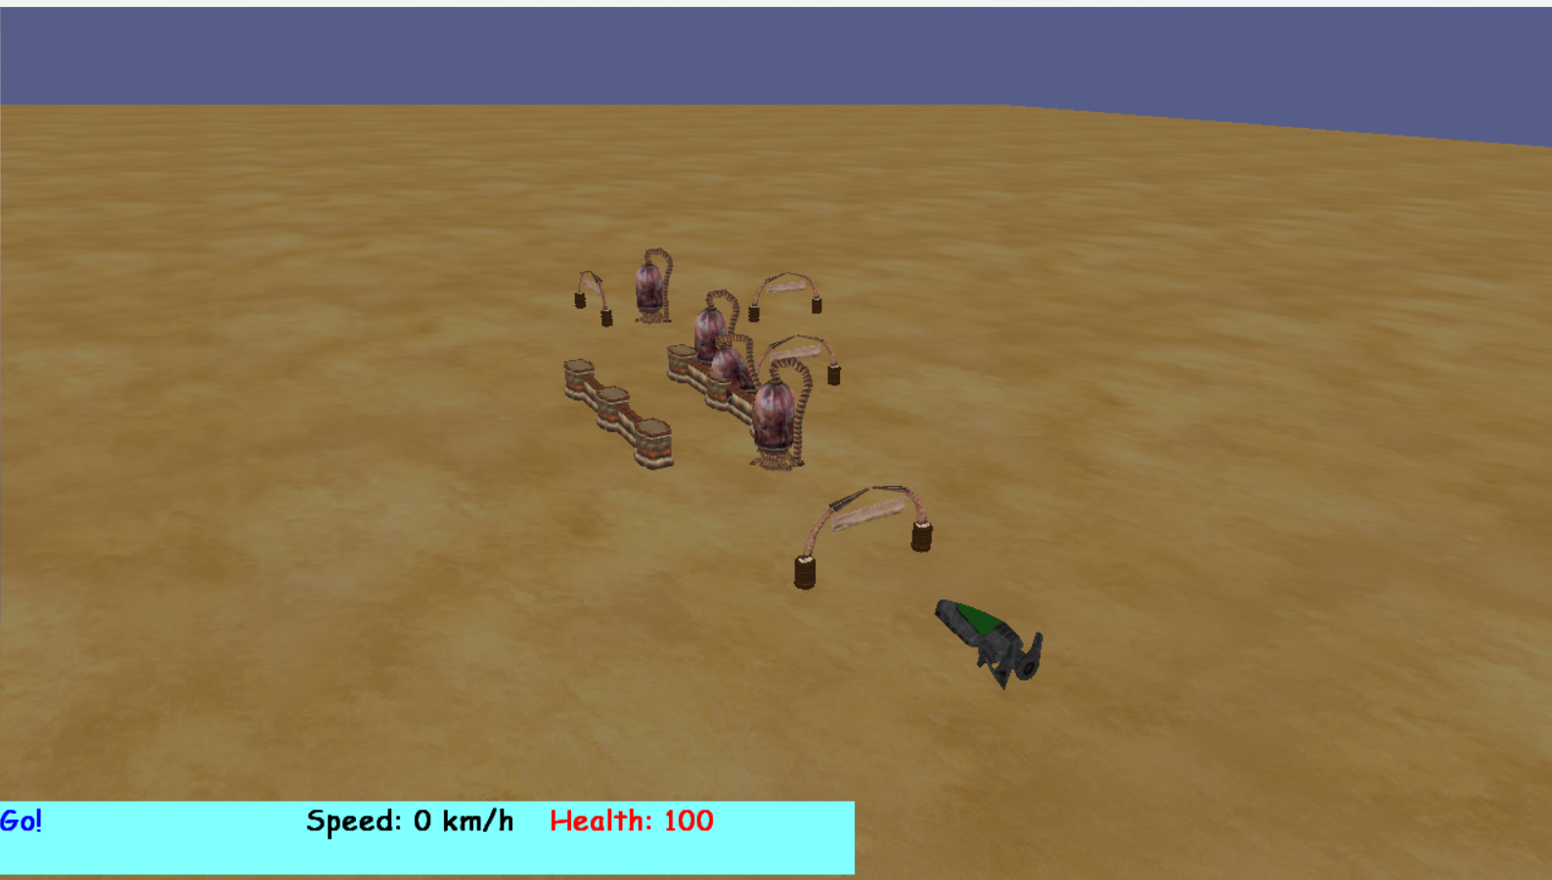

- Scale: 2 TL Engine units = 1 meter.
- Start: ( 0, 0, -20) meters Car’s Starting position.

- Checkpoints:
- Checkpoint 1: (0, 0, 0)
- Checkpoint 2: (10,0,120) – rotated 90 degrees around Y axis
- Checkpoint 3: (50,0,100)
- Checkpoint 4: (25,0,56)

- Isles:
- Isle 1: (-10, 0, 40)
- Isle 2: (10, 0, 40)
- Isle 3: (-10, 0, 56)
- Isle 4: (10, 0, 56)
- Isle 5: (-10, 0, 72)
- Isle 6: (10, 0, 72)

- Walls:
- Wall 1: (-10, 0, 48)
- Wall 2: (10, 0,48)
- Wall 3: (-10, 0, 64)
- Wall 4: (10, 0, 64)

- Tanks:
- Tank 1: (5,0,30)
- Tank 2: (15,0,70)
- Tank 3: (20, 0, 110)
- Tank 4: (12, -0.75, 50) – buried and rotated 45 degrees on x axis.

- From (0,0,0,) to (10,0,120) $\sqrt{{10}^{2}+{120}^{2}}=120.41 units$
- From (10,0,120) to (50,0,100) $\sqrt{{40}^{2}+{20}^{2}}=44.72 units$
- From (50, 0, 100) to (25, 0, 56)$\sqrt{{25}^{2}+{44}^{2}}=50.60 units$
- From (25,0,56) to (0,0,0) $\sqrt{{25}^{2}+{56}^{2}}=61.32 units$

- Total track length in Tl engine units = 277.05 units.
- Total track length in meters = $\frac{277.05}{2}=138 meters$.

